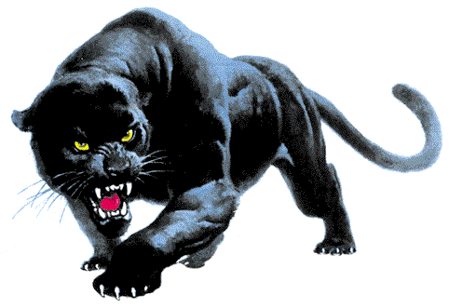
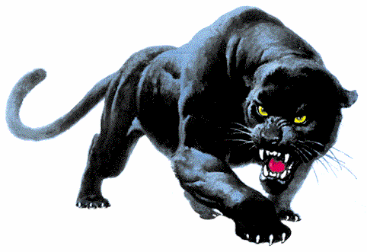
University Preparatory School
Field Trip Permission

Parent/Guardian Permission

I hereby give my permission for _____________________________________________
(Print Student Name)
to attend the following school field trip. Parent Signature __________________ Date: ________

Description of Activity: Half Day AP Environmental Science

Date(s): Thursday April 15th Location: Whiskeytown / Tower House Info: Mr. Raudman for details

Time: Meet and Depart at classroom 185 during 6th @12:30, Take roll then leave by 12:35
Arrive at Tower House by 1:00, Participate in Carbon Sequestration study and monitoring (lunch, water AND HIKING SHOES required. )
Depart back to U Prep by 3:00 for arrival at 3:25.

Supervising Staff Member(s): Tad Raudman

In case of accident or injury I give permission for the supervising staff member to authorize medical treatment. I understand that I am responsible for any expense incurred as a result of obtaining the necessary medical care.

Parent/Guardian Signature: _____________________________________
Parent/Guardian Contact Number(s): _____________________________________
Emergency Contact: _____________________________________
Insurance Policy/Group Number: ___________________________________
Family Doctor Name and Telephone Number: ____________________________________

____ I do not give my student __________________, permission to attend this half day field study and understand that my student will need to stay at U Prep, with another teacher during the normal class periods and may need to make up an alternative assignment set up by Mr. Raudman.

_____ I give my student ________________ permission, but will need transportation for him/her.

_____ I give my student ________________ permission and can drive to/from the field study and transport _____ additional students in my vehicle. I have met DMV and School requirements for driving other students for the 2014-2015 school year.

Hard copy permission slips are due Wednesday April 15th by 2nd period
Teacher Signatures: P6:______ Tutorial:_____

