Ecosystem:______________________ Partner 1 Name:__________________________ Partner 2 Name:_________________________ Period:______
Unit 3: Edible Food Web & Energy Pyramid Project
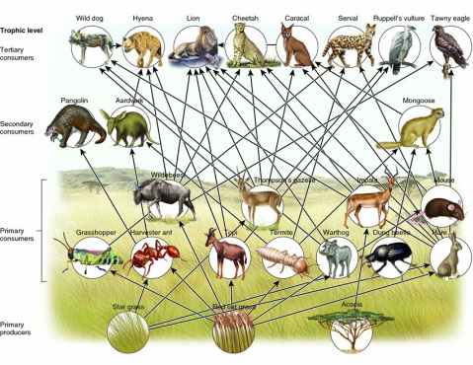
For this project you and a partner will research an ecosystem and create an edible food web that exists within that ecosystem. Your food web will need to include 12 different organisms that are arranged in at least 4 different trophic levels within the ecosystem. Your food web must include at least one species for each trophic level (producers, primary consumers, secondary consumers, tertiary consumers, etc.) and you must include 2 species of decomposers (bacteria and/or fungi). Biome:_______________Ecosystem:___________________
Organisms in your edible food web must be created from cookies (sugar, etc.) that are shaped or decorated to look like the organisms themselves. All organisms will be decorated with only edible products. Each organism must be connected to another by an arrow of some kind (frosting, yarn, etc.) that designates the flow of energy/matter through the ecosystem. Your food web will be displayed on a platter naming and representing the biome and ecosystem you and your partner choose. It is due in class on Monday October 6th.
Accompanying your food web you will need a small cup for each representative organism’s population. Each cup will be filled with 1-10 M&M or Skittle “Calorie counters” of differing colors representing the amount of energy that exists amongst the population of organisms found in each trophic level of the food web. Within the ecosystem you will use the candy “Calorie counters” to build an Energy Pyramid that represents a functional ecosystem, remembering the rule of thumb regarding energy pyramids. Only ______% of the energy from a lower trophic level makes its way up one trophic level, while _______% is lost as “waste” energy to the environment as heat and material waste.
In your energy pyramid, groups should use the Kilocalorie unit of energy represented by the capitalized unit Calorie. Students will need to make a colored key for their different candy “Calorie counters” that lists how many Calories each colored counter represents. As a guideline, the total amount of energy contained among all of the organisms that are primary producers (first trophic level) should be in the millions of Calories. All other trophic levels (ie. primary, secondary & tertiary consumer levels) connected in your food web can only have as much energy as the level below will support. Total energy contained in all populations of each trophic level will need to be calculated and illustrated using additional “Calorie counters” of various colors that have energy amounts listed on the project key. Organisms that are decomposers will not need to have energy counters associated with them.
During grading your teacher may ask you and your partner to change the amount of energy in the 1st trophic level (among producers) which will require you and your partner to rearrange the amount of energy (Calorie counters) that will be available in populations in all other trophic levels connected in your food web.
Please pay close attention to your energy pyramid calculations, as mistakes may result in:
- Organisms being removed from the food chain if they are unsupported
- Points being deducted for incorrect energy pyramid calculations
- Ecosystem disturbance and/or collapse
Along with your Food Web and Energy Pyramid you must also include and label one Food Chain in the food web, using different colored frosting, yarn, etc. You and your partner will need to turn in one rubric handout with both of your names included to earn your project grade.
This project will be graded out of 90 points with the following breakdown:
- 12 correct organisms connected in the food web (12pts) __________
- 12 organisms located in the correct trophic levels (12 pts) __________
- Energy Pyramid calculations are correct and support all organisms (2 pts ea. - 20 pts) __________
- Correct food chain marked/labeled and Included (6 pts) __________
- Colored Key for “Calorie counters” (10 pts) __________
- Energy Pyramid recalculation (2 pts for each correct population’s energy - 20 pts) __________
- Neatness, style and presentation of your Biome/Ecosystem (10 pts) __________
- Extra Credit for detailing an Aquatic/Marine ecosystem of the pacific northwest + 5 points

Total Score:______________________

